THE TULLEYS TRIAL
SPORTING TRIAL
Sunday 1st November 2020

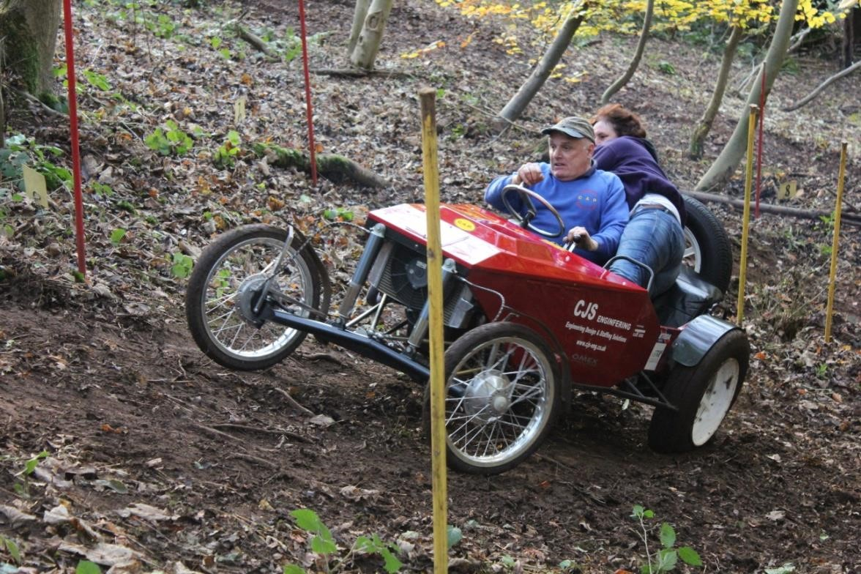
At
Tulleys Farm
Turners Hill
Nr Crawley
West Sussex
RH10 4PD

A QUALIFYING ROUND OF THE BTRDA & Motorsport UK CHAMPIONSHIPS

Supplementary Regulations

- The Kentish Border Car Club will organise a Clubmans sporting trial at
Tulleys Farm, Turners Hill, near Crawley, RH10 4PD on Sunday 1st November 2020

- The Meeting will be governed by the General regulations of Motorsport UK
(Incorporating the provisions of the International Sporting code of the FIA), These SR’s and any written instructions the organising club may issue for the event.
- Motorsport UK Permit number: 119240
- The event is open to all fully elected members of the organising club and members of the following invited clubs. B.T.R.D.A, NPTCC, 750 Motor Club, Midland Trials Car Club, L&NCMC, Camel Vale MC, Bristol MC, holding an RS Clubman Motorsport UK Competition License. Club membership cards and competition licenses will be inspected at signing on. Passenger club membership cards will also be inspected at signing on.
- The event is a round of the 2020 Motorsport UK Sporting Trial
Championship, the 2020 B.T.R.D.A. Sporting Trial Championship and the BTRDA® Allrounders Championship (permit no. tba )
- Public Roads will not be used to link sections. There will be 8 to 10 tests on private land to be attempted 3 times. The entry will be split into groups starting at different hills to enable the programme to be completed.
- Scutineering starts at 9-00 am. This will be a visual check, in line with covid restrictions. First test at 10-30 am.
- Awards to be presented as follows.
Best overall performance of the day.
Best Performance Red Class. Independent and Live axle
Best Performance Blue Class Independent and Live axle
Best Performance Rookie (Novice) Class .
Best Performance by a Post Historic Class driver

- The entry list opens on the publications of these SR’s and closes on the 28th October 2020. No late entries will be accepted. The Entry Fee for over 25’s is £35.00. The Entry Fee for 25’s and under is £25.00 All entries must be completed on the official MS UK entry form as this will cover your signing-on on the day, and accompanied by the appropriate fee. Bank transfer to: Kentish Border Car Club. Account 71581340 sort 60-19-02 (with the wording”Tulleys20 your name”). Entry fees will be refunded if the secretary of the meeting is notified by telephone or letter of a competitor’s cancellation by 12 noon on the 31st October 2020
- All entries to be emailed to the Secretary of the meeting: Alison Barnes at:stephen@theasparagusfarm.co.uk
- The maximum entry for the meeting is 50, the minimum is 15. Should the minimum figure not be met the organisers have the right to cancel the meeting.
- Other officials are: Club Steward: Cliff England
Chief scrutineer: John Bundock Clerk of Course: TBA
Chief Marshal: John Bundock
- Provisional results will be published as soon as possible after the event, Any protests to be made in accordance with 05.1.
- Competitors will be identified by numbers, which will be provided at signing on.
- All other GR’s of Motorsport UK apply as written.
- No person will drive a competing car on the site except the authorised competitor.
- All competing cars must be fitted with an effective silencer. A noise test may be carried out
- The use of motorcycles or quad bikes on the site is restricted to authorised persons only.
- A first Aider will be in attendance
- Toilet facilities will be available
- Permitted tyres: Vredestein T-Trac 2, Maxxis MA510N, Nankang CX668 and Toyo 330. Any cars in the Post Historic class can use tyres in accordance with T14.8.1 & T14.8.2.

