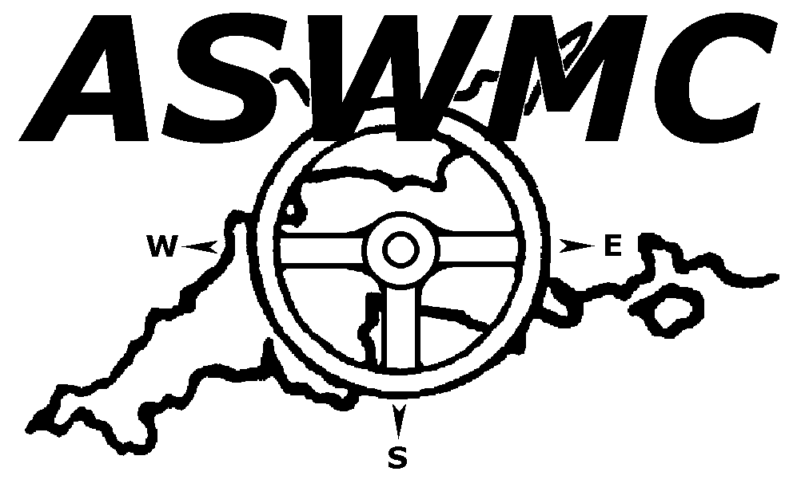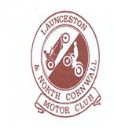

LAUNCESTON AND NORTH CORNWALL MOTOR CLUB LTD

DAVID AYERS TRIAL 12th SEPTEMBER 2021

Additional Supplementary Regulations

- Launceston and North Cornwall Motor Club Ltd. will promote a Clubman permit Sporting Car Trial for the David Ayers Trophy at Trevilla Farm, Marshgate, Camelford, Cornwall, PL32 9YN on Sunday 12th September 2021. Map Ref. 190 145911.

- The Meeting will be governed by the General Competitions Rules, Standing Supplementary Regulations of Motor Sport UK. Incorporating the provisions of the international Sporting code of the FIA, these SRs and any written instructions of which the promoting Club may issue for the event.

- A Motor Sport UK permit applied for.

- The event is open to all full elected members of the organizing Club (membership £10.00) & members of Northern Phoenix Trials Car Club and any contenders in the BTRDA and ASWMC Sporting Trial Championships and all members of Clubs that are running rounds in the BTRDA Sporting Trials Championship.

- All drivers & passengers over 17 must hold a MotorSport UK RS Clubman licence & appropriate motor club membership card(Club passenger membership £1.00)

- THE EVENT is a qualifying round of the 2021 Motor Sport UK , 2021 ASWMC Sporting Trial and 2021 BRTDA Sporting Trial Championships.

- SCRUTINEERING will start at 9.00 am. First test will start at 10.30 am. Any Competitor not signed on by 10.00 am may be excluded.

- THE START will be at Trevilla Farm. Public roads will not be used to link sections and there will be 8 sections – there will be 3 rounds (weather permitting). The entry will be split into groups starting at different sections.

- All vehicles must comply with Motor Sport UK Technical Regulations. Tyres must comply with 2021 MSA Yearbook 12.9.3. All vehicles must have efficient silencing, any vehicle considered by the scrutineer to be too noisy will not be allowed to start. All cars in the post historic class can use tyres in accordance with T14.8.1 & T14.8.2.

- The Event will consist of six classes as follows: :
- RED Driver Independent Suspension as per BTRDA listings
- RED Driver Live Axle as per the BTRDA listings
- BLUE Driver Independent Suspension as per the BTRDA listings
- BLUE Driver Live Axle as per the BTRDA listings
- GREEN Class Novice drivers as per the BTRDA listings
- CLUBMAN
- POST HISTORIC

- THE AWARDS WILL BE PRESENTED AS FOLLOWS:-
DAVID AYERS TROPHY and REPLICA – Best Overall Performance
THE FRANK AYERS TROPHY and Replica – Best Performance in Class 6
CLASS AWARD – for best performance in each class(subject to at least 4 entrants)
OTHER AWARDS will be presented at organizers’ discretion.

- THE ENTRY LIST opens on receipt of Regs. and closes finally on Tuesday 7 ^{th} September 2021. THE ENTRY FEE is £42.00 ). All entries must be made on an official entry form and accompanied by the appropriate fee.

- SECRETARY OF THE MEETING - Mrs P Gomm, New Haven, Darkey Lane, Lifton, Devon, PL16 0DY (01566 784348: gommfamily@btinternet.com.

- The maximum entry for the meeting including reserves is 50. The minimum overall is 12 and for each class is4. Should any of the minimum figures not be reached the organizers have the right to either cancel the meeting or amalgamate classes as necessary.
Entry fees may be refunded if notified two days before the event.

15 Other Officials are:
CLUB STEWARD J Caudle.
CLERK OF THE COURSE W Kelly
SCRUTINEER TBA

16 Provisional results will be published asap after the end of the event .

17.Any protests must be made in accordance with 6.2.6
18. Competitors will be identified by numbers which will be issued at signing on.

19. Marking and Penalties will be as printed in the appropriate section of the RAC MSA General Regulations (T6).

20. Where concussion is diagnosed following an accident the new Motor Sport UK rules A11-A11.8 apply

21. All other Regulations of Motor Sport UK apply as written.

22. The Finish will be at Trevilla Farm – where Provisional Results will be announced.

FIRST AID SERVICE WILL BE IN ATTENDANCE

Directions: From A39 6 miles East of Camelford – near Otterham Cafe, turn north towards Marshgate. After 500 yards L into gated track to farm. Park in the large paddock provided with toilet.

NB. Use of motorcycles on the site is restricted to authorized persons only at the request of the land owner.
PLEASE NOTE THE LANGLEY FAMILY WILL NOT BE ABLE TO PROVIDE THE NORMAL CATERING FACILITY THIS YEAR. THEREFORE , NO CATERING ON SITE.

COVID 19 .All covid protocol & guidelines at the time of the event will be applicable. Further details to follow with final instructions.

